12.01.25 ANKITA GUPTA

22BCE3327



Name : ANKITA GUPTA

Registration Number : 22BCE3327

Course Code : BCSE301P

Subject Title : Software Engineering Lab

Lab Slot : L15+L16

Guided by : DEEPIKA J

1. Analysis and Identification of the suitable process models.

**Brief Description of the Project - Abstract**

The restaurant faces challenges in meeting the evolving demands of consumers seeking seamless dining experiences. Right now, there is not a good system that does this, which makes it hard for restaurants to run smoothly and are not able to give customers the satisfactions they want.

On looking further into the problem, I found that there is lack of integration of dine-in and take away services, resulting in bad customer experience and restaurant inefficiencies. Order-taking methods in dine-in can be time consuming and prone to errors. Simultaneously, absence of take-away orders hinders the restaurant’s ability to satisfy the customer need.

A simple yet reliable solution. An app, or rather, a platform that combines both dine-in and take away services. This solution will address the challenges of order processes, enhance communication between customers and restaurant staff and to create a more satisfying and efficient dining experience for all stakeholders involved.

* 1. Define the scope and boundaries of your project.

What parts of the process are included, and what are the intended outcomes?

**Scope and Boundaries of the Project**

**Project Scope**

1. Key Functionalities:

- Integrated Ordering System: Build a platform that consolidates both dine-in and takeaway orders, allowing users to effortlessly choose their preferred dining mode.

- Digital Menu Accessibility: Provide an interactive menu that customers can explore, customize, and use to place precise orders.

- Real-Time Order Tracking: Implement live status updates for customers, detailing order confirmation, preparation progress, and completion times.

- Minimized Errors: Streamline the order-taking process through automation to reduce manual mistakes and enhance order accuracy.

2. User Experience Enhancements:

- For Customers:

- Easy-to-navigate interface for placing, modifying, and tracking orders.

- Multi-payment options for a smooth checkout experience.

- For Restaurant Staff:

- A centralized dashboard to manage and oversee orders from both dine-in and takeaway services.

- Notifications for updated orders and special requests in real time.

- Data insights into customer preferences and operational trends to optimize service.

3. Communication Improvements:

- Enable efficient communication between customers and staff for customizations or clarifications.

- Provide automated notifications for order confirmations, preparation progress, and pick-up readiness.

4. Customer Retention Features:

- Implement rewards programs for repeat customers.

- Gather post-service feedback to refine the dining experience continually.

5. Technology Deployment:

- Design the platform for both mobile and web environments to ensure accessibility.

- Seamlessly integrate the platform with existing restaurant systems, such as POS and kitchen displays.

**Project Boundaries**

1. Exclusions:

- The platform will not support delivery logistics, focusing exclusively on dine-in and takeaway functionalities.

- Inventory management features will not be part of the initial phase.

- Full customization of branding or restaurant-specific features will be considered for later development phases.

2. Limitations:

- Restaurants are responsible for maintaining up-to-date menus and prices on the platform.

- Adoption of the platform requires training for restaurant staff to ensure efficient use.

- Internet connectivity will be essential for the platform's seamless operation.

3. Dependencies:

- Integration with restaurant systems, such as point-of-sale (POS) or kitchen management software.

- Availability of hardware like tablets or POS terminals for restaurant staff.

**Intended Outcomes**

1. For Customers:

- A simplified and user-friendly ordering process for both dine-in and takeaway.

- Enhanced convenience through reduced waiting times and improved accuracy in orders.

- A modern dining experience supported by technology.

2. For Restaurants:

- Improved efficiency in operations by unifying dine-in and takeaway services.

- Reduction in manual errors and better accuracy in order management.

- Access to valuable customer insights to make data-driven decisions for service improvements.

3. Overall Impact:

- Creation of a comprehensive, technology-driven platform that bridges the gap between dine-in and takeaway services.

- Enhanced customer satisfaction and operational efficiency, setting a new standard for restaurant service delivery.

- A scalable solution adaptable to diverse restaurant models and operational needs.

1.2 Clarify Your Goals:

• List your primary objectives

1. Integrate Dine-In and Takeaway Services:

Develop a single platform that combines dine-in and takeaway operations for a seamless customer experience.

1. Enhance Order Accuracy:

Automate order processing to minimize human errors in taking and managing orders.

1. Streamline Communication:

Create a direct and efficient communication channel between customers and restaurant staff for requests and updates.

1. Improve Operational Efficiency:

Simplify and centralize order management for restaurant staff to handle dine-in and takeaway orders more effectively.

1. Increase Customer Satisfaction:

Provide customers with a user-friendly, time-saving solution that enhances their overall dining experience.

• Set measurable target outcomes: Aim for specific, achievable benchmarks to assess your success.

1. Customer Adoption:

Achieve at least 75% of customers using the platform for order placement within the first three months of launch.

2. Error Reduction:

Reduce order-related errors by 90% compared to traditional manual methods within the first six months.

3. Operational Efficiency:

Decrease average order processing time by 50% within the initial rollout phase.

4. Customer Satisfaction:

Attain an 80% or higher positive feedback rating from customers using the platform within six months.

5. Repeat Users:

Encourage customer retention, with 60% of users placing more than one order through the platform within three months.

6. Restaurant Staff Engagement:

Train 100% of restaurant staff to effectively use the platform within the first two months post-implementation.

1.3 Assess Your Constraints:

• Define the available timeline: What is the deadline for achieving your desired

outcomes?

* Project Kickoff: Start development in Week 1 after securing approval and resources.
* Prototype Completion: Deliver a functional prototype within 3 months of project initiation.
* Testing Phase: Conduct a rigorous testing phase over 1 month to identify and resolve any bugs or usability issues.
* Post-Launch Review: Gather feedback and release initial updates within 2 months post-launch to refine the platform further.

• Consider resource limitations: What skillsets are available to execute the process?

* Software Developers: Expertise in app and web development, with a focus on front-end and back-end technologies (e.g., React, Node.js, Python, or Java).
* UI/UX Designers: Ability to create intuitive, user-friendly interfaces tailored for both customers and restaurant staff.
* Data Analysts: Skilled in collecting and interpreting data for feedback and platform improvements.
* Project Manager: Experience in coordinating teams, setting milestones, and ensuring timely delivery.

Skillsets Lacking:

* Marketing and User Acquisition: Limited expertise in promoting the platform to customers and restaurants.
* AI Expertise: Insufficient resources to implement advanced AI-driven features like predictive analytics or natural language processing in the first phase.

5. Identify the suitable process model for your project. Justify your answer

**Software Development Process Model**

The ideal software development process model for the given project would be the **incremental model**.

**Incremental Process Model**

The incremental model applies linear sequences in a staggered fashion. Each linear sequence produces deliverable “increments” of a software.

In this model, the first increment is often a core product i.e. basic requirements are addressed but many supplementary features remain undelivered. As a result of evaluation plan is developed for next increment. The plan addresses the modification of the core product to better meet the needs of customer and delivery of additional features and functionality. This process is

repeated until the final product is produced.

Incremental process model is fitting for my project due to the following reasons:

1. **Iterative Nature**: The development of this app involves evolving requirements, user feedback and market trends. The iterative nature allows for revisiting and refining specific aspects of app based on evaluations

2. **Continuous Enhancement**: Each iteration helps us to focus on specific features, allowing for a more manageable and targeted improvement process.

3. **Quick release of core features**: This is helpful for getting essential functionalities such as menu browsing, order placement and payment processing.

4. **Early user involvement**: It promotes continuous user feedback, ensuring that final product aligns closely with customer expectations and preferences. Regular reviews and feedback sessions provide opportunities to identify and rectify problems.

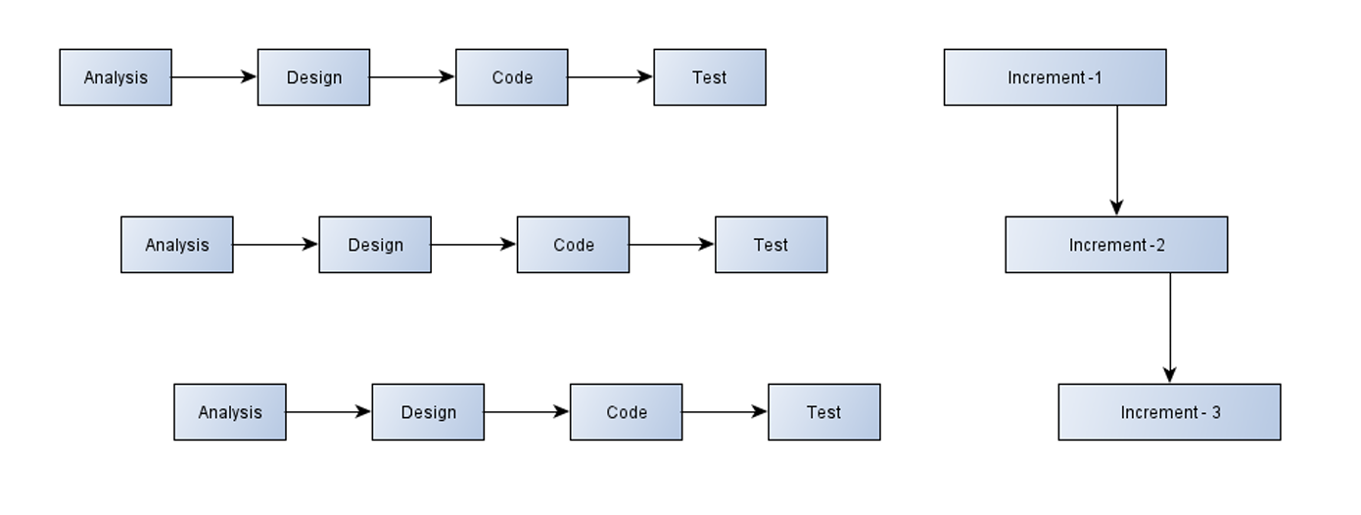

6. For this project, you will be using GitHub to manage your code.

* Create a new GitHub repository for this project.
* Commit your code to the repository frequently, using descriptive commit messages.
* Submit the link to your GitHub repository now and during your final project demo.

1. Work Break-down Structure (Process Based, Product Based, Geographic Based and Role Based) and Estimations (GANTT chart and PERT chart)

**Process Based**

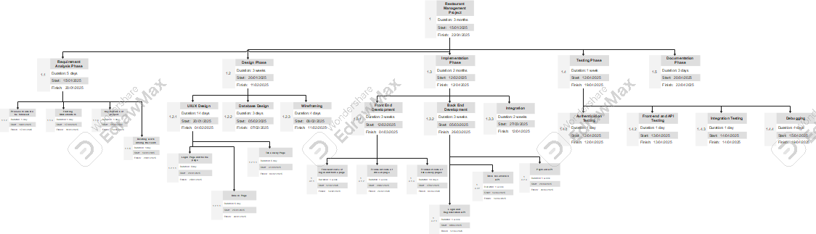

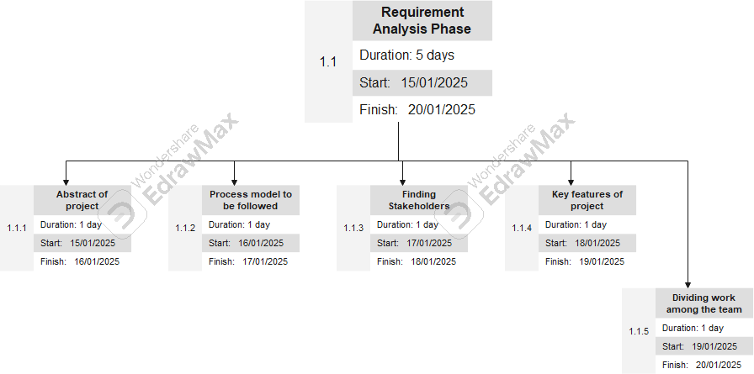

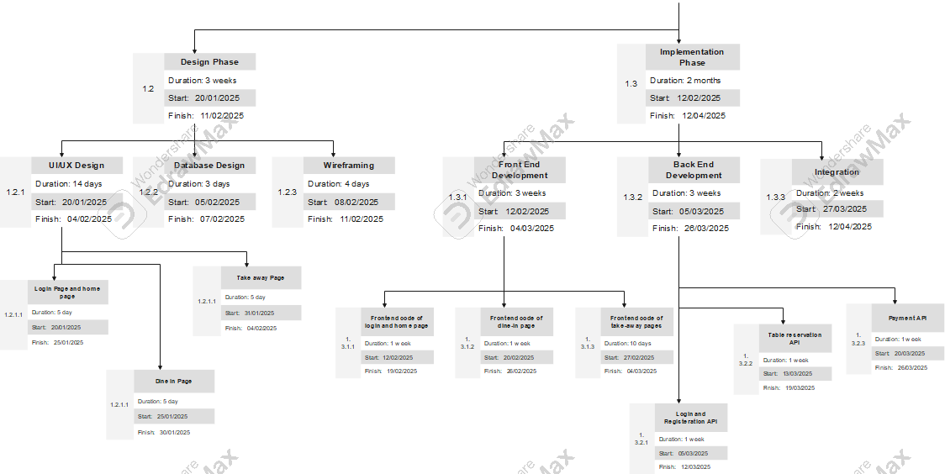

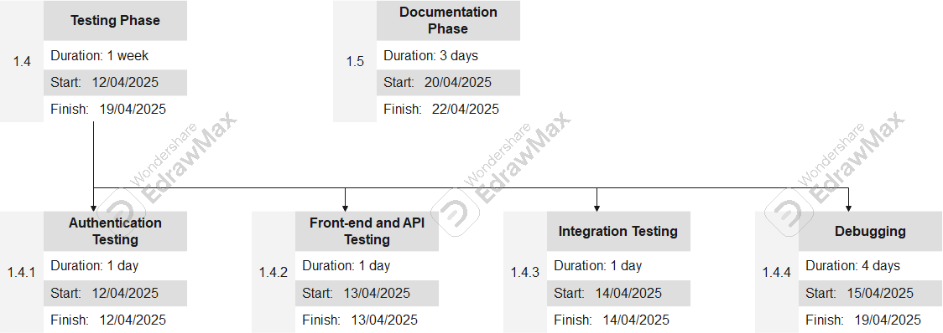

**Geographic Based**

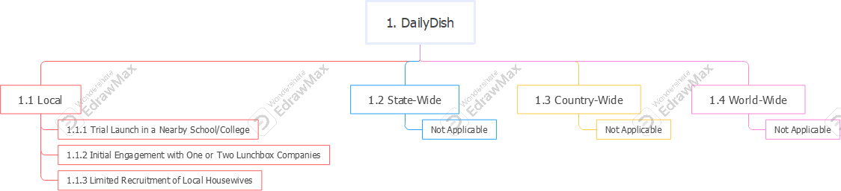

**Role Based WBS**

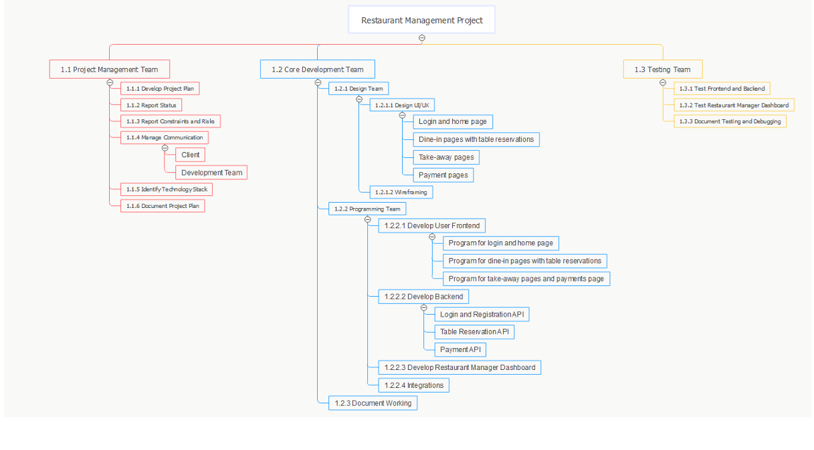

**Process Based WBS**

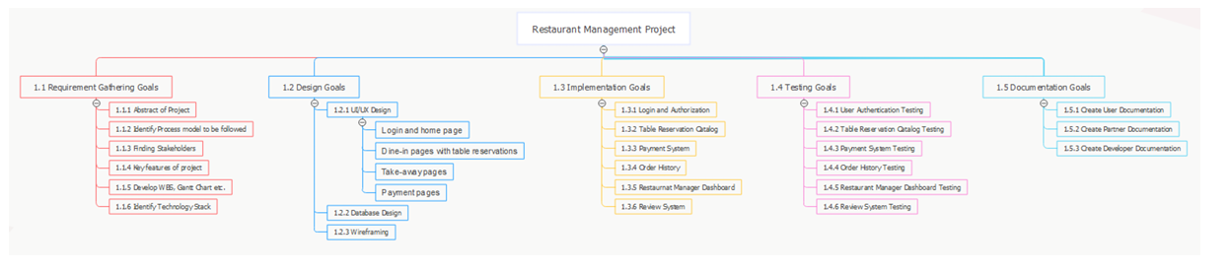

**Gantt Chart**

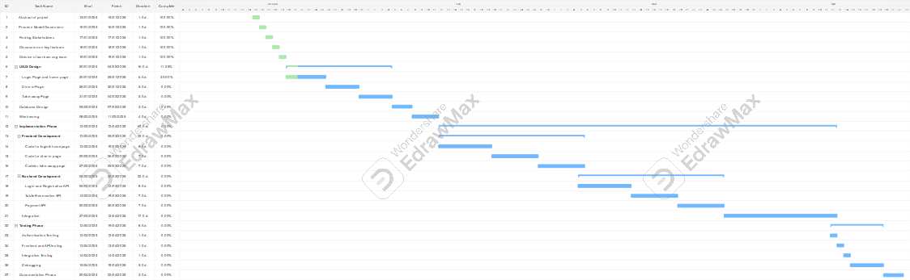

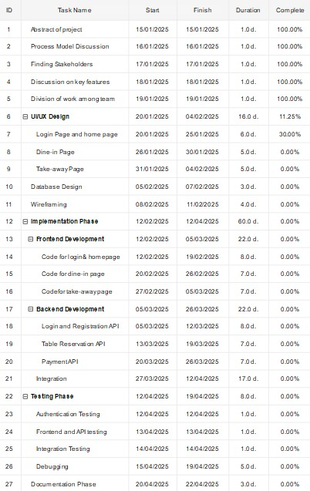

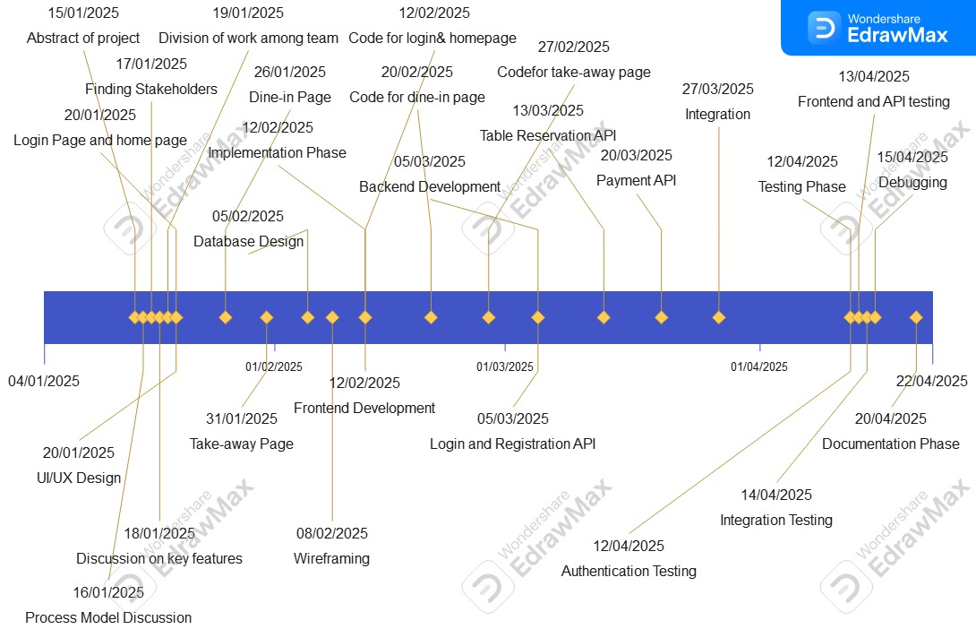

**PERT Chart**

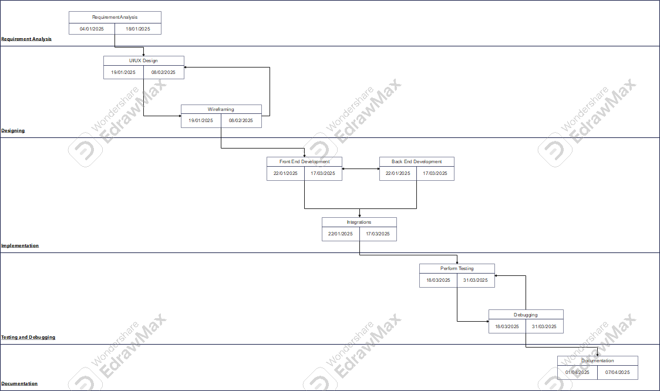

1. Prepare SRS for your project as per the IEEE template.

1. Introduction

1.1 Purpose

The SRS report for the restaurant app project serves purposes, all aimed at providing clear and detailed understanding of project requirements.

Key purposes of SRS report: requirement clarification, stakeholder communication, scope definition, basis of agreement, testing foundation, risk management, client understanding, documentation for technical details. The SRS report serves as a foundational document that guides the entire software development lifecycle, promoting effective communication, understanding, and collaboration among all stakeholders involved in the project.

1.2 Scope

It is within the scope of SRS to describe the specific system requirements of the project. This will include performance requirements, system requirements, and project assumptions. Any specific detail that is needed about the standards or technology used to define these requirements, constraints, and assumptions are within the scope of this document.

The scope of the SRS document is to serve as a comprehensive guide that aligns all stakeholders, communicates the project's requirements clearly, and provides a foundation for successful development, testing, and deployment of the restaurant app.

1.3 References

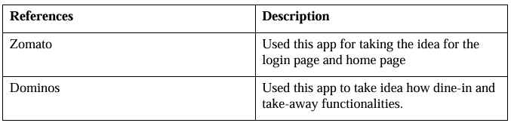

1.4 Use Case Diagram

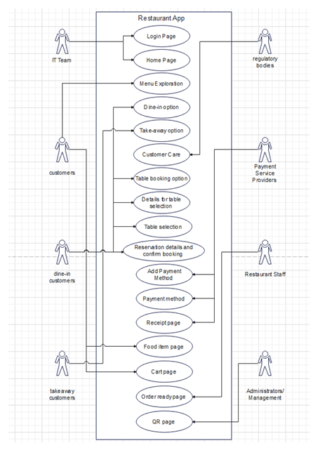

**Entity Relationship**

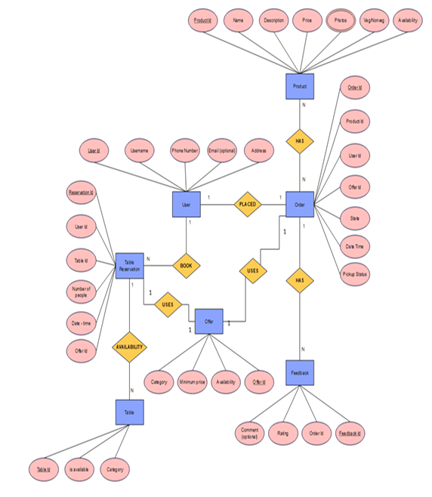

**Data Flow**

**Level-0 DFD**

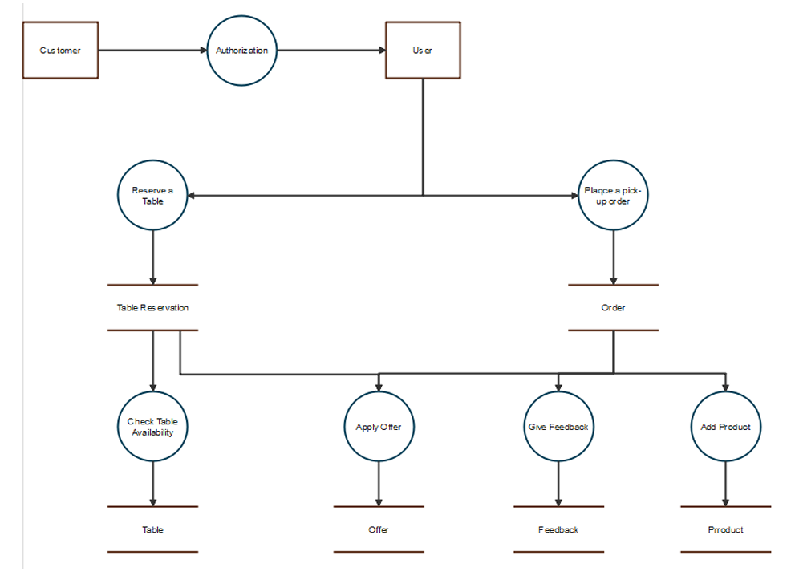

**Level-1 DFD**

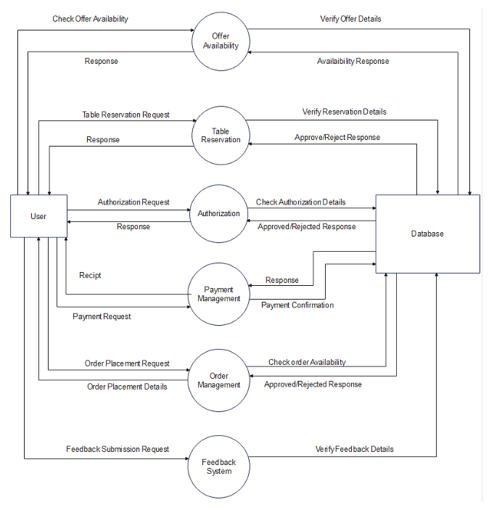

2. Specific Requirements

2.1 Functional Requirements

1. **User Authentication**:

Purpose: This is used to verify user id by verifying their mobile number using otp or

taking their digital footprints by using OAuth for google authentication

• Requirement: Users should be able to log in with either a phone number or an

email address.

• Requirement: The system should securely store and manage user credentials.

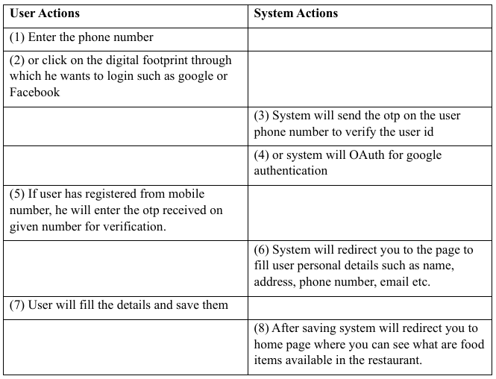

2. **Menu Exploration:**

Purpose: This is used to search what all items are available in the restaurant, browse

the menu and what are top selling items

• Requirement: Users must have the ability to browse menu items.

• Requirement: The app should display menus for three meals of the day.

• Requirement: Users should be able to view top items and available offers/schemes.

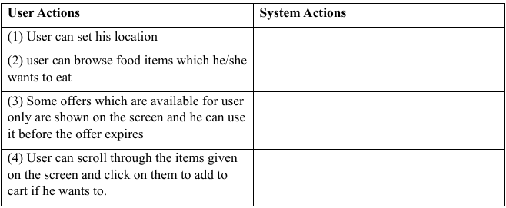

3. **Dine-In Functionality:**

Purpose: This is used for user to see what are the offers available for dine-in and how

many tables are available for reservation

• Requirement: Users can select the food type for dine-in.

• Requirement: The app should direct users to a table reservation page.

• Requirement: Users need to fill in details such as the number of people, date, and time for the reservation.

• Requirement: After selecting a table and details, users should confirm the reservation by making a minimal payment.

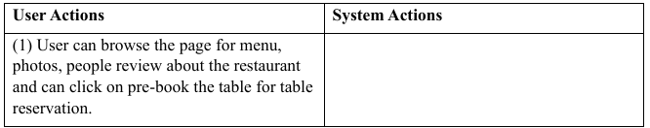

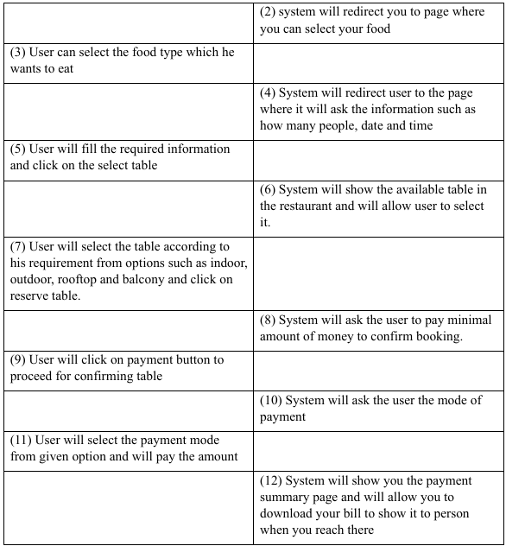

4. **Take-Away Functionality:**

Purpose: This is used for user to choose from food, drinks and desserts and add them to cart for order to take-away with him

• Requirement: Users can choose from food, beverages, or dessert for take away.

• Requirement: A menu should appear for users to select items and add them to the cart.

• Requirement: Users can adjust the quantity of items in the cart and apply available offers.

• Requirement: Users receive a notification when the take-away order is ready.

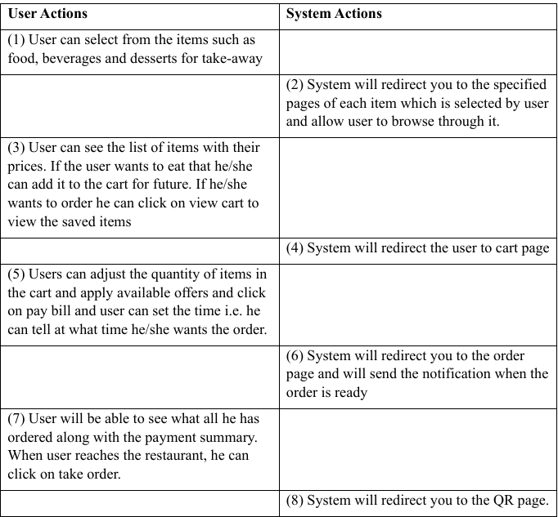

5. **Order Pickup with QR Code:**

Purpose: This is used by user to show unique QR code to receive their take-away order.

• Requirement: Users receive a notification when their order is ready for pickup.

• Requirement: Users should display a unique QR code to receive their take away order.

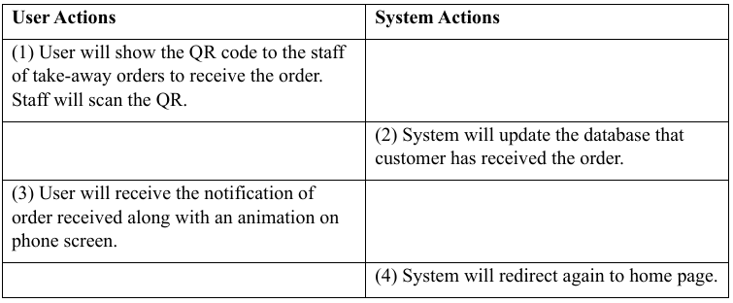

2.2 Non-Functional Requirements

1. **Performance:**

• Requirement: The app should provide a responsive and seamless user experience.

• Requirement: Loading times for menus and order processing should be optimized.

2. **Security:**

• Requirement: User authentication and payment transactions must be secure and comply with industry standards.

• Requirement: User data, including personal and payment information, should be encrypted and protected.

3. **Reliability:**

• Requirement: The system must be reliable, minimizing downtime and disruptions.

• Requirement: Notifications should be delivered reliably to users.

4. **Usability:**

• Requirement: The app should have an intuitive and user-friendly interface.

• Requirement: The menu and ordering processes should be straightforward and easy to navigate.

5. **Compatibility:**

• Requirement: The app should be compatible with both iOS and Android platforms.

• Requirement: The app interface should be responsive and adaptable to various device screen sizes.

6. **Scalability:**

• Requirement: The system should be designed to handle a growing number of users, menu items, and orders.

7. **Data Privacy and Compliance:**

• Requirement: The app should comply with data privacy regulations and ensure the secure handling of user data.

• Requirement: User consent for data usage should be explicitly obtained and documented.

8. **Notification System:**

• Requirement: The notification system should be real-time and push notifications to users' devices promptly.

9. **Feedback Mechanism:**

• Requirement: The app should prompt users to provide feedback, and the feedback mechanism should be easy to use.

• Requirement: User feedback should be stored and analysed for continuous improvement.

10. **Offline Capability:**

• Requirement: The app should have limited offline functionality, allowing users to browse menus and view previous orders.